Chimzim Ogbondah

Loft Ben Othmane

SE 339

24 February 2021

Assignment 2

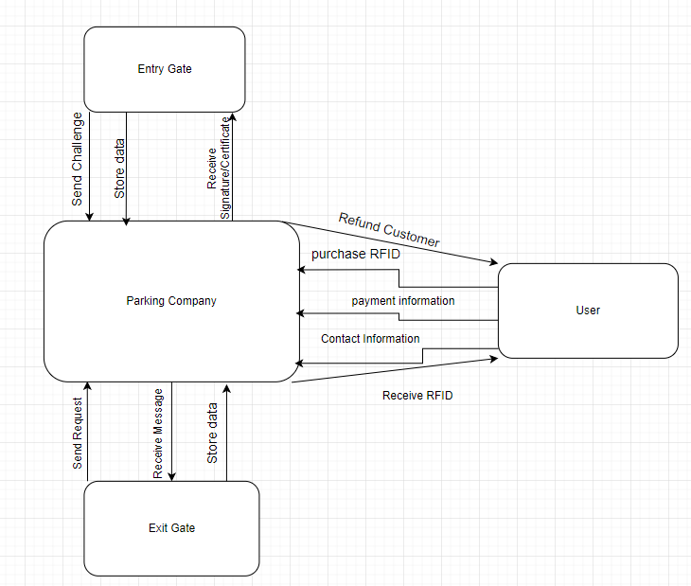

* 1. Assumptions: The software being delivered will be able to store the company data in the central systems, and also instruct the gates on how and when to keep transaction data. On the certificate/message action it should be assumed that the gate either opens or denies access. Assume software also is compatible with RFID to interact with gates and record parking history. The customers payment information will be used when generating payment requested and failed reports. During the claim process the claim company will be able to use the software stored on the central system. The central system will send information from the failed payments.
  2. I believe this solution works because it gives a loose idea of what the company will provide and what the customer needs to provide. In the assumptions it helps address the certain functionalities of the internal system to justify differing use cases.
  3. I believe this solution works because it touches and addresses all the use cases from the assignment descriptions and lays out how the system shall loosely interact to achieve the desired results of the stakeholders.



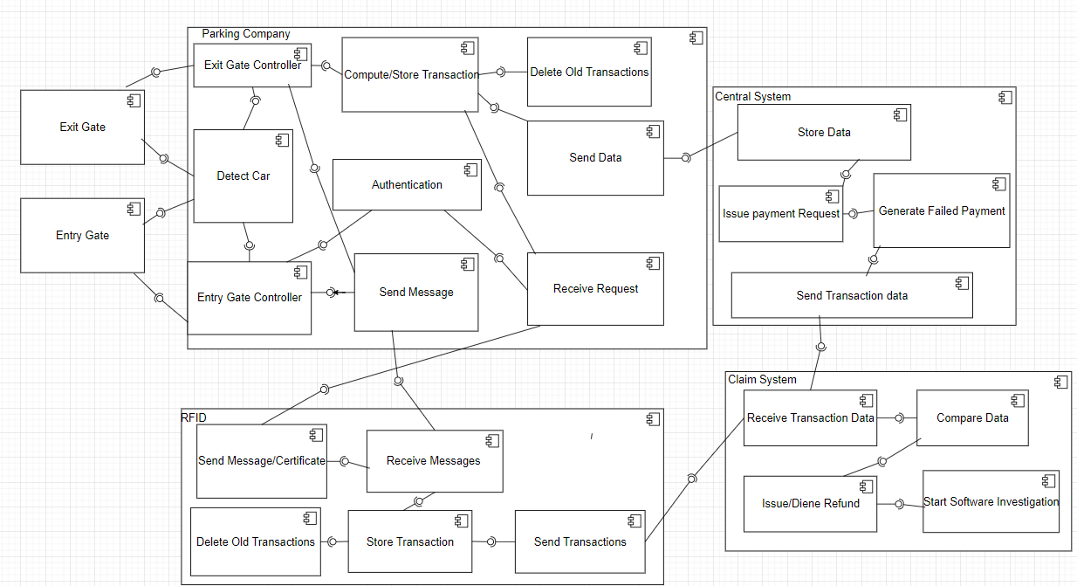

* 1. Assumptions: During the compute/store transactions the parking history is noted to create the transaction where tax is added at the end. Since everything will be deleted off the controller during idle time worst case scenario was assumed and a small amount of memory would be allocated for this history. The exit gate does not need to do any authentication, so it just computes the transaction and then sends the information back to the customer. On successful transfer it will open the gate. Since user information is sent, on issue refund it will use the parking company’s customers payment information to reimburse them. It should also be noted that it only starts an investigation when an issue is refunded and will notify the company.
  2. I believe this solution works because it covers all of the use cases and then shows the inter component communication of the entire design. Note that in Authenticate Request this is where controller request is handled between controller and vehicle RFID and then opening of the gates upon successful authentication. During this process entry and exit time and gate is noted. This is used to create a transaction with added tax which is then stored. While in idle after successfully sending data to the central system the system deletes the stored transaction data.
  3. Another viable solution is to have the entry and exit gate controller request authentication in one system. This would be another option because it would hold the same software API in all gates.

1. 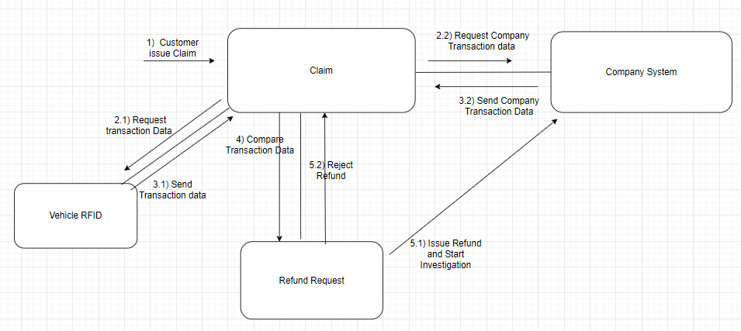
   1. Assumptions: The data being compared from the company’s side comes from the issued failed payments. Also, when the refund is issued it goes back to the company to pay the customer/destroy the issued payment.
   2. I believe this solution works because it covers the use case where the user issues a claim the claim company compares both the user’s RFID data and the central data from the parking company. Then based on results payment is issued and a software investigation begins, or it is denied.
2. 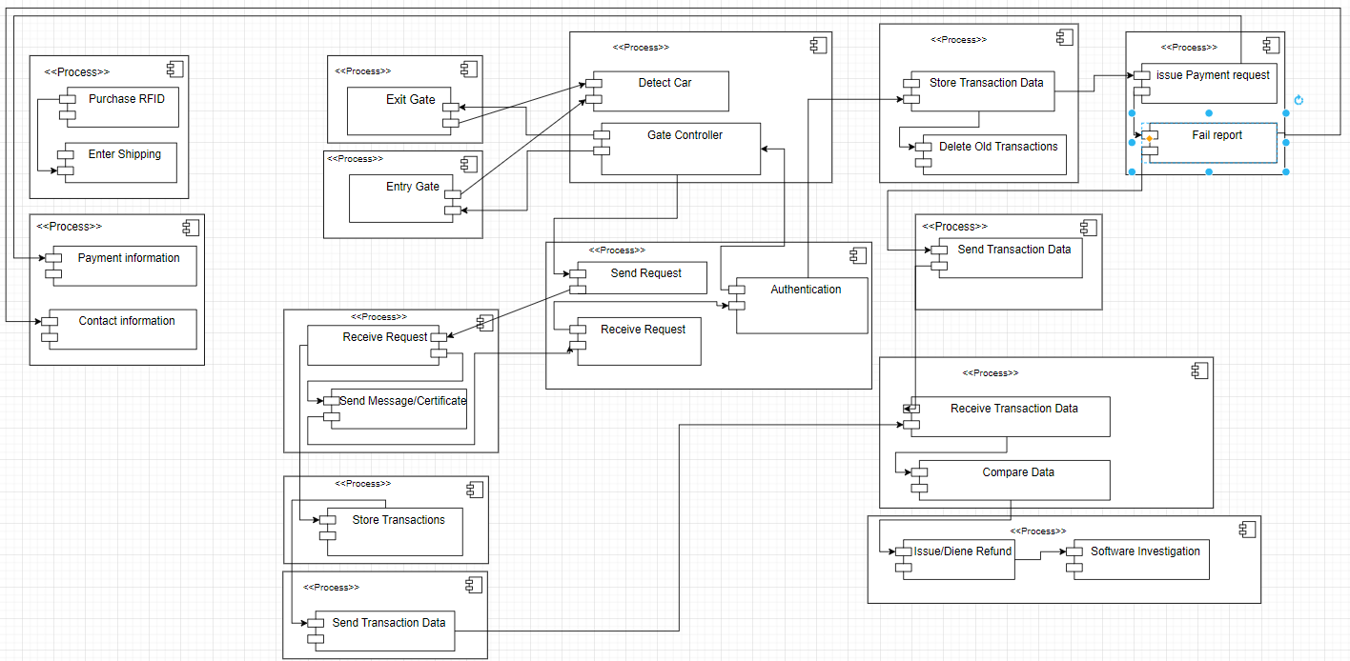
   1. Assumptions: installation of the RFID is not part of the software scope. However, since the company issues the payment a software investigation is started the company reimburses the customer too. The user’s information is also stored on the central system but in a separate place from the transaction data. However, all transactions are linked to the customer through the RFID purchased.
   2. It covers all the uses cases and splitting them up into processes. It shows the processes for controlling the gates. The message communication and authentication. The storge of data and then the issuing of reports. It also shows how messages and storage is handled for the RFID. Also showing how payments are issued and deal with the customers information and then issuing failed results. Installing the RFID however is not part of the software scope and so it was omitted from the design.